August Safety Awareness
Over the next month, children will be heading back to school. As a driver, you must learn to share the road. Here are some tips to help ensure students make it to school without being injured:
- Be on the lookout for school zone signs and always obey the speed limit
- Yield to pedestrians in crosswalks, and take extra care in school zones
- Watch for school crossing guards and obey their signals
- Do not block crosswalks
- Never pass a vehicle stopped for pedestrians
- Never pass other vehicles while driving in a school zone
- Never pass a bus loading or unloading children
- Never make U-Turns while driving in a school zone
- The area 10 feet around a school bus is the most dangerous for children, remember to stop far enough back to allow them to safely enter and exit the bus
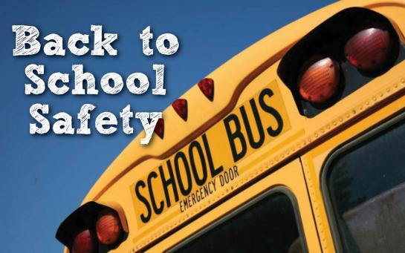
- Be aware of children near schools, bus stops, sidewalks, in the streets and in the school parking lots

